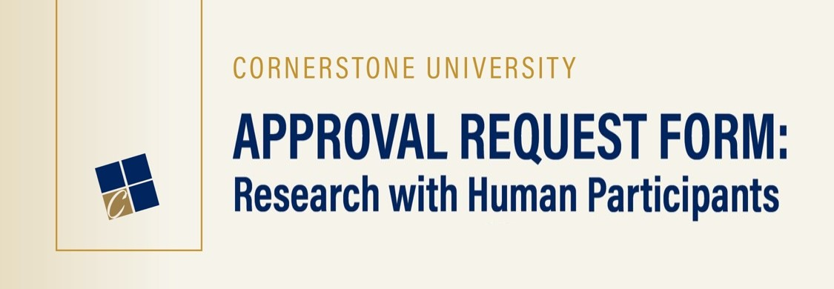
Study Information
Title of Study:
Date research will begin: Expected completion date:
If proposal for external funding:
Agency: Deadline:
Department chair’s (or designee’s) signature, acknowledging awareness of study:
CU-IRB Training
CU-IRB training is required of all investigators prior to review of the CU-IRB Approval Request Form.
Training is available for Cornerstone students, faculty and staff through Moodle. To access:
- Type “Protecting Human Research” in the search box in Moodle and click “Go.”
- Click on “IRB - PROTECTING HUMAN RESEARCH PARTICIPANTS TRAINING” when it appears.
- Enter “CORNERSTONE” as the Enrollment Key and then click “Enroll Me.”
After creating an account, begin with the introduction module and follow the instructions. Once you’ve completed all modules and all quizzes, print out the certificate and submit it along with this proposal form to the CU-IRB chair.
All investigators have completed the required CU-IRB training within the last three years, and a copy of the certificate has been submitted with this application.

Investigator(s)

Principal Investigator:
Department:
Doctoral Student Faculty Other:
Phone: Date: Email:
Additional Investigator(s)’ Name(s):
Approval Information
For research conducted by students or non-faculty staff:
This research involving human or animal participants, if approved, will be under the direct supervision of the following faculty adviser (considered the principle investigator):
Faculty Adviser: Department:
Phone: Date: Email:
For research conducted by external investigators:
This research has been approved by an external IRB. The approved proposal will be submitted with this application.
This research has not been approved by an external IRB.
Research Information

1. PROJECT DESCRIPTION: Provide a description of the proposed research by responding to each of the topics below.
a. Describe purpose of proposed research.

b. Outline method of selection and recruitment of targeted participants

c. Identify targeted participants:
Age Range: Sample Size (N=): Sex:
d. Identify targeted participants in vulnerable populations: (Check all that apply.)
Please note: Proposed studies involving any vulnerable population will require a full IRB review.

None
Minors* (Under 18 years. Age range: )
People with cognitive impairments
Prisoners
Pregnant or
lactating women
Individuals with
disabilities
Military personnel
Wards
Institutionalized individuals
Non-English speaking individuals

Other subjects whose life circumstances may interfere with their ability to make free choice in
consenting to take part in research.
Please specify:
*If you identified minors as a target population, please attach procedures to be used in obtaining their agreement or assent to participate, in addition to the consent of their authorized representatives, such as parent or guardian.
e. Describe participant incentives, follow-ups, and/or compensation to be used, if any.

f. Describe the nature of data to be collected (e.g., qualitative/quantitative, observational, questionnaires, scales, interviews, etc.)

g. Describe procedures and instruments to be used (i.e., include a complete copy of any interview or questionnaire instruments to the bottom of this document.) Be as explicit as possible about the steps involved.

h. Describe plan for data dissemination (e.g., poster, manuscript, presentation).

2. POTENTIAL RISK: By marking “x” in the following box, the researcher(s) acknowledge that all research has the potential for risk.
Yes
- All research entails some level of risk, though perhaps minimal. Below, describe in detail any psychological, social, legal, economic or physical risk that might occur to participants. Include a description of your plans to mitigate these risks.

- Describe the measures you will take in case any harm happens to your participants during any of your procedures.

- Illegal activities: Do the data to be collected relate to any illegal activities? (Mark an “x” in the appropriate box below):
No illegal activities are involved in this proposed research.
Yes. (Please attach explanation of illegal activities).
Please note: Proposed studies involving any illegal activities will require a full IRB review.

3. POTENTIAL BENEFIT: University policy requires that risk from and/or burden of participation be outweighed by potential benefits to participants and/or humankind in general.
a. Identify potential benefits to PARTICIPANTS resulting from this research.

b. Identify potential benefits to SCIENCE or SOCIETY resulting from this research.

4. CONSENT: All participants must know that their participation is completely voluntary; therefore, all studies must include informed consent. You must obtain a declaration of agreement or assent from minors, in addition to the consent of their authorized representative, such as a parent or guardian.
a. What is the consent process to be followed in this study? Explain how you will be obtaining consent from participants.

b. Is deception or incomplete disclosures involved in this study?
No.
Yes. (If yes, please provide a justification as well as a plan for the debriefing process.)

5. SECURITY PROCEDURES: Please describe how participants are protected from the potentially harmful use of the data collected in this research by responding to each of the topics below:
a. Describe measures planned to ensure anonymity or confidentiality.

b. Describe methods for storing data while study is underway.

c. Please describe how long you plan on keeping your data, and how you plan on destroying your data when the time comes to do it.

Please include a copy of the documents below, within this file (i.e., submit only one file, containing all the required documents):
The Informed Consent. (See question 4.)
All instruments to be used in this research (e.g., interviews forms, questionnaires, surveys). (See question 1g.)

