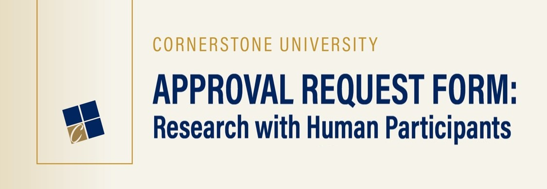

**STUDY INFORMATION**

**TITLE OF THE STUDY:**

Date the study will begin: Expected completion date:

If this is a proposal for external funding:

Agency: Deadline:

Department chair’s (or designee’s) signature, acknowledging awareness of the study:

**CU-IRB TRAINING**

All investigators must take the CU-IRB training before submitting the CU-IRB Approval Request Form.

Training is available for Cornerstone students, faculty, and staff through Brightspace. To access:

1. On the My Home page of Brightspace, click "Discover" in the top left corner.

2. Type “IRB” in the search box and click “Go.”

2. Click on “IRB - PROTECTING HUMAN RESEARCH PARTICIPANTS TRAINING” when it appears.

3. Click “Enroll in Course.”

Begin with the introduction module and follow the instructions. Once you’ve completed all modules and all quizzes, please print out the certificate and submit it along with this proposal form to the CU-IRB chair.

( ) All investigators have completed the required CU-IRB training within the last three years, and a copy of the certificate has been submitted with this application.

**INVESTIGATOR(S)**

Principal Investigator:

Department:

( ) Doctoral Student ( ) Faculty ( ) Other:

Phone: Date: Email:

Additional Investigator(s)’ Name(s):

**APPROVAL INFORMATION**

**FOR RESEARCH CONDUCTED BY STUDENTS OR NON-FACULTY STAFF:**

This research involving humans, if approved, will be under the direct supervision of the following faculty adviser (considered the principal investigator):

Faculty Adviser: Department:

Phone: Date: Email:

**FOR RESEARCH CONDUCTED BY EXTERNAL INVESTIGATORS:**

( ) An external IRB has approved this research. The approved proposal will be submitted with this application.

( ) An external IRB has not approved this research.

**RESEARCH INFORMATION**

**1. PROJECT DESCRIPTION:** Describe the proposed research by responding to each topic below.

a. Describe the purpose of the proposed research.

b. Outline the method of selection and recruitment of targeted participants

c. Identify the targeted participants:

Age Range: Sample Size (N= ): Sex:

d. Identify the targeted participants in vulnerable populations: (Check all that apply.)

Please note: Studies involving any vulnerable population will require a full IRB review.

( ) None

( ) Minors* (Under 18 years. Age range: )

( ) People with cognitive impairments

( ) Prisoners

( ) Pregnant or lactating women

( ) Individuals with disabilities

( ) Military personnel

( ) Wards

( ) Institutionalized individuals

( ) Non-English speaking individuals

( ) Other subjects whose life circumstances may interfere with their ability to make free choices in consenting to take part in research.

Please specify:

*If you identified minors as a target population, please attach procedures to obtain their agreement or assent to participate, in addition to the consent of their authorized representatives, such as parents or guardians.

e. Describe participant incentives, follow-ups, and/or compensation to be used, if any.

f. Describe the nature of data to be collected (e.g., qualitative/quantitative, observational, questionnaires, scales, interviews, etc.)

g. Describe procedures and instruments to be used. Include a complete copy of any interview or questionnaire instruments at the bottom of this document. If you utilize equipment, include the brand name and model. Be as explicit as possible about the steps involved.

h. Describe your plan for data dissemination (e.g., poster, manuscript, presentation).

**2. POTENTIAL RISK:** By marking “X” in the following parentheses, the researcher(s) acknowledge that all research has the risk potential.

( ) Yes

a. All research entails some level of risk, though perhaps minimal. Below, describe any psychological, social, legal, economic, or physical risk to participants. Include a description of your plans to prevent possible injuries associated with these risks.

b. Describe the measures you will take if any harm happens to your participants during your procedures.

c. Illegal activities: Do the data to be collected relate to any illegal activities? (Mark an “x” in the appropriate box below.):

( ) No illegal activities are involved in this proposed research.

( ) Yes. (Please attach an explanation of illegal activities.)

Please note: Studies involving illegal activities will require a full IRB review.

**3. POTENTIAL BENEFIT:** University policy requires that the risk from and/or burden of participation be outweighed by potential benefits to participants and/or humankind in general.

a. Identify potential benefits to PARTICIPANTS resulting from this research.

b. Identify potential benefits to SCIENCE or SOCIETY resulting from this research.

**4. CONSENT:** All participants must know their participation is voluntary; therefore, all studies must include informed consent. You must obtain a declaration of agreement or assent from minors and the consent of their authorized representative, such as a parent or guardian.

a. What is the consent process to be followed in this study? Explain how you will obtain consent from participants.

b. Is deception involved in this study?

( ) No.

( ) Yes. (If yes, please provide a justification and a plan for the debriefing process.)

**5. SECURITY PROCEDURES:** Please describe how participants are protected from the potentially harmful use of the data collected in this research by responding to each of the topics below:

a. Describe measures planned to ensure anonymity and/or confidentiality.

b. Describe methods for storing data while the study is underway.

c. Please describe how long you plan on keeping your data and how you plan on destroying it when the time comes to do it. (All records associated with this study should be kept for at least three years.)

Please include a copy of the documents below within this file (i.e., submit only one file containing all the required documents):

( ) The Informed Consent. (See question 4.)

( ) All instruments to be used in this research (e.g., interview forms, questionnaires, surveys). (See question 1g.)

**6. FINANCIAL CONFLICT OF INTEREST:**

( ) There is no financial conflict of interest to declare.

( ) There is a financial conflict of interest. Please describe the financial conflict of interest:

Please describe the procedures you will use to minimize the effects of the financial conflict of interest on your study: